Table of Contents

Introduction 4
Goals 5
Objectives 6
Location 7
Historical Perspective 9
Summary of 2000 Reexamination Report 10
Demographic Profile 10
Analysis of Population 10
Population Change 10
Seasonal Population Growth (Migration) 10
Population Projections 12
Population by Age Cohort 12
Households and Families 12
Housing Units by Tenure and Vacancy Status by Type 13
Housing Units 14
Land Use Element 15
Existing Land Use 15
Residential 17
Commercial 17
Community Design Plan 25
Business Zones (B-1, B-1A, and B-2) 25
Center Design Guidelines 25
Humanism, Pedestrianism, and Streetscape 25
Open Space and Core Community Greens 26
Mixed and Multiple Uses 26
Design Vocabulary 26
Maintenance 27
Housing Plan Element 28
Size of Residential Structures in Square Feet 28
Density 29
Floor Area Ratio 30
Mass and Scale 35
Flood Control 35
Building Height 36
Architecture 39
Height Exceptions 41
Building Coverage 41
Roof Pitch 41
Third Story 42
Garages 42
Decks 42
Yard Setbacks 42
Bulkhead/ Mean High Water Line 43
Drainage 46
Green Space 46
Landscape 46
Zoning Ordinance 47
Circulation Plan Element 48
Functional Highway Classification System 48
Freeways 48
Primary Arterials 48
Secondary Arterials 48
Major Collectors 48
Minor Collectors 49
Local Streets 49
Bus System 49
Linear Recreation and Bikeways 49
Parking study 50
Off-Street Parking 50
Parking Requirement 51
Driveways 52
Parking Lot Design Standards 53
Circulation and the Land Use Element 53
Utility Service Plan Element 54
Water supply 54
Drainage control; flood control; stormwater management 54
Sewage and waste treatment 54
Solid waste disposal and recycling 55
Conclusion 57

Index of Tables

Table D-1 – Population Change 1950-2000 10
Table D-2 – Population Projections 12
Table D-3 – Population by Age Cohort – Year 2000 12
Table D-4 – Households and Families 12
Table D-5 – Housing Units by Tenure and Vacancy Status 13
Table D-6 – Authorized Dwelling Units 1990 to 2000 14
Table LU1 – Lot Count by Zone 15
Table LU2 – Parcel Counts with Breakdown by Lot Frontage 16
Table LU3 – Percentage of Land Area Within Each Zone District 16
Table HP1 – Number of Demolitions by Year 28
Table HP2 – Average Square Foot Comparison 29
Table HP3 – Density as Permitted in Existing Zoning Districts 30
Table HP4 – R-1A Zone Floor Area Ratios (FAR) 31
Table HP5 – R-1B Zone Floor Area Ratios (FAR) 31
Table HP6 – R-1C Zone Floor Area Ratios (FAR) 32
Table HP7 – R-2A Zone Floor Area Ratios (FAR) 33
Table HP8 – R-2B Zone Floor Area Ratios (FAR) 34
Table HP9 – B-1A Zone Floor Area Ratios (FAR) 34
Table HP10 – B-2 Zone Floor Area Ratios (FAR) 35
Table CP1 – “Parking Requirements for Residential Land Uses (a) 51
Table U1– Capacity Assurance Program Community Flow 55
Table U2 - Solid Waste Tonnage 1994-2000 56

Table of Figures

Figure 1 - Location Map 8
Figure 2 – Existing Land Use Plan R-M Zone South (Area #1) 19
Figure 3 – Existing Land Use Plan B-1 Business Zone (Area #2) and B-1A Business Zone (Area # 3) 22
Figure 4 – Existing Land Use Plan B-2 Zone West (Area #4) 24
Figure 5 – Borough of Avalon General Elevation Reference Map 37

Introduction
New Jersey State law requires municipalities to update their Master Plans every six years in the form of a reexamination report. This report must examine the major land development problems and objectives present at the time of the last report and their current status; any changes that have occurred to the Master Plan’s underlying assumptions, policies and objectives; and make recommendations for any changes to the master plan’s objectives, policies or standards. Particular attention must be paid to the density and distribution of population and land uses, housing, motorized, and non-motorized circulation, the conservation of natural resources and energy (recycling) and changes in State, county, and municipal policies and objectives.

The last full master plan for the Borough of Avalon was adopted in January of 1979. Master Plan Activity since that time includes the following:

1982 – Reexamination
1988 – Reexamination and Housing Plan Element
1994 – Reexamination
2000 - Reexamination
2002 – Reexamination and Build Out Analysis

The Municipal Land Use Law (MLUL) requires that every master plan contain a statement of objectives, principles, assumptions, policies and standards upon which the constituent proposals for the physical, economic, and social development of the municipality are based. This reexamination report considers the land use, housing, circulation, utility service, and community design plan elements of the master plan. This reexamination seeks to validate existing land uses, policies, and objectives when applicable and propose changes to them where appropriate.

The report includes a complete housing element and fair share plan consistent with the requirements of the Council on Affordable Housing (COAH).

The MLUL states that,
“The governing body may adopt or amend a zoning ordinance relating to the nature and extent of uses of land and of buildings and structures thereon. The ordinance shall be adopted after the planning board has adopted the land use plan element and the housing plan element of a master plan, and all the provisions of such zoning ordinance or any amendment or revision thereto shall either be substantially consistent with the land use plan element and the housing plan element of the master plan or designed to effectuate such plan elements.”
Furthermore,
“The zoning ordinance shall be drawn with reasonable consideration to the character of each district and its peculiar suitability for particular uses and to encourage the most appropriate use of the land. The regulations in the zoning ordinance shall be uniform throughout each district for each class or kind of buildings or other structures or uses of land, but the regulations in one district may differ from those in other districts.”

Specifically, this plan is intended to expand upon the recommendations of the 2002 Reexamination Report and Build Out Analysis provide specific recommendations for zoning ordinance and site plan and subdivision ordinance amendments.

The Goals and Objectives of this study as determined by the Planning Board are as follows:

Goals
Preserve community character and promote a desirable visual environment through creative development techniques and good civic design and arrangements.

Promote inter local service agreements with barrier island municipalities having similar economic interests.

Promote the conservation of valuable natural resources, dunes, bay waters, beaches, etc.

Provide adequate light, air, and open space.

Promote improved resident safety and emergency notification programs including the use of cell tower communications.

Promote appropriate population densities contributing to the well being of persons, neighborhoods, and the community as a whole and preservation of the environment.

Develop environmental resource inventory through GIS, Maps and Information.

Promote and improve environmental programs.

Promote economic development of the commercial districts.

Plan for affordable housing.

Promote various uses by providing sufficient space in appropriate locations for a variety of residential, recreational, and commercial uses and open space.

Ensure community has working infrastructure plan and funding.

Objectives
Control building coverage, height of buildings, density, setbacks, scale, and mass to preserve light, air, and open space.

Expand on economically advantageous inter local shared services agreements with Stone Harbor, Sea Isle City and Ocean City.

Encourage additional second floor residential uses in the business districts to generate activity and interest along the streetscape, generate pedestrian traffic, and create a customer and employee base for existing and future commercial uses.

Promote a healthy environment for restaurants in the commercial districts.

Prepare COAH ordinances.

Validate plan for B1 Zone on Ocean Drive.

Review and update Zoning and Site Plan ordinances as appropriate.

Protect our dunes, endangered wildlife and species.

Control the parking of large trucks from the Business District on adjacent residential streets.

Control the use of Borough streets for th storage of boats/trailers and commercial trailers.

Ensure water ways are clear and open for economic, recreational, and fishing use.

Reduce traffic congestion and on-street residential parking demand by improving off-street parking, enforcing parking laws, encouraging public transportation, public safety and enhancing public parking lots

Encourage opportunities for pedestrians through a community wide transportation system.

Preserve our critical coastal resources, (i.e.: beach).

Encourage performing arts and cultural development through the Avalon Free Public Library and Borough Recreation Department programs, events, classes, and website.

Preserve and enhance hotel/motel district.

Location
The Borough of Avalon is located in the middle-eastern portion of Cape May County and is surrounded by the Atlantic Ocean to the east; Stone Harbor to the south; the intercoastal waterway, salt marshes, and Middle Township to the west; and Townsend’s Inlet and Sea Isle City to the north. The island on which Avalon is located projects further east towards the Atlantic Ocean compared to many of its neighboring islands to the north and south.

Figure 1 - Location Map

Historical Perspective
The Borough of Avalon was incorporated in 1891 when the island seceded from Middle Township. When Avalon was first developed, the early subdivision layouts provided lot widths of fifty to sixty feet, which were very generous at the time compared to other seaside resorts in New Jersey. Early land use ordinances established business and residential zones and wide public promenades. Later ordinances established minimum lot sizes of four thousand square (4,000) feet, front yard building setbacks of fifteen (15) feet, side yard setbacks of five (5) feet, and building heights of forty (40) feet.

Other important community and public agency decisions include, establishing the dune line to preserve the remaining dune environment along the oceanfront and preservation of undeveloped meadowlands. These conservation efforts contribute to Avalon’s charm and community character. Another aspect of Avalon’s continued success, as an attractive resort destination has been the enforcement of zoning, flood plain, and construction regulations that govern development in the community.

Summary of 2000 Reexamination Report
The 2000 Reexamination Report validated the 1994 Reexamination Report’s suggestion that the Zoning Ordinance requires revisions. In addition, the report discussed the community’s desires to evaluate parking, traffic, open space, noise, light, air, water, sewer, stormwater runoff, community facilities, and community services. The report specifically explains that the entire zoning ordinance requires review including zoning districts, permitted uses, lot area, building and lot coverage, building setbacks, building height, parking, and home occupations. Furthermore, the report states that a build out analysis is required which considers the number of buildings, number of buildings by type, sewerage flow, water consumption, traffic projections, parking demand, population projections, support services demand, school enrollment projections, recreational demand, and electrical demand. Finally, the report recommends that changes be made to the site plan and subdivision ordinance, zoning ordinance, flood control ordinance, land use procedures ordinance, and municipal affairs.

Demographic Profile
The following is an overview of the characteristics of population, housing, employment, and labor in the Borough.

Analysis of Population

Population Change

Table D-1 – Population Change 1950-2000

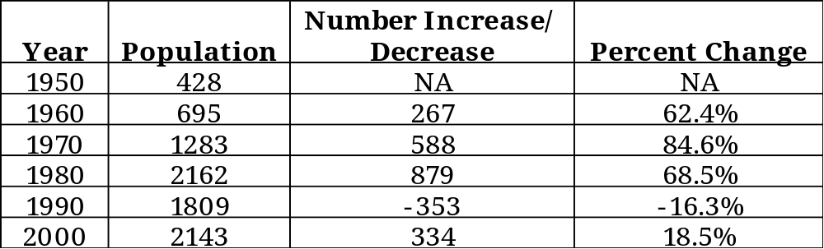
Source: US Bureau of Census

The year round population in Avalon has remained fairly steady in the last twenty years from 1980 to 2000. In fact, there is only of difference of 19 persons between 1980 and 2000. There have been no significant increases in the year round population such as the large amount of growth between 1960 and 1970.

Seasonal Population Growth (Migration)
Seasonal population data is difficult to obtain because the U.S. Bureau of Census does not compile data for seasonal migration. The Cape May County Planning Department estimates seasonal population or seasonal migration. The department estimates that the seasonal population figure is between 36,967 and 42,248 people. That estimate is based upon the number of dwelling units (5281) multiplied by seven (7) or eight (8) persons or occupants.

The New Jersey State Police are required by law to provide annual mean population (AMP) estimates for resort municipalities in New Jersey in order to prepare per capita crime statistics. The State Police state very clearly that these estimates should not be used for any other purpose because the estimates are not a complete measure of seasonal population because they include only those living in rental housing units or in vacant year-round housing. Not counted are the many day visitors and persons who occupy campgrounds, hotels, motels, or bed and breakfast establishments or who stay with friends and relatives.

The State Police determine the Annual Mean Population using the following formula:
AMP = 12P + 3SP
12
Where AMP equals Annual Mean Population; P equals Population and; SP equals Seasonal Population.

5,762 = 12(2,143) + 3(14,476)
12
According to the State Police the seasonal population is 43,428 persons over the three-month summer period or summer season. The Cape May County Planning Board’s estimate appears reasonable in light of the State Police figure.

A seasonal population of 36,967 increases the year round population in the community 1725% or 17 times. A seasonal population of 42,248 increases the year round population in the community 1,971% or 20 times. These figures represent a significant increase in the population due to tourism.

Population Projections

Table D-2 – Population Projections

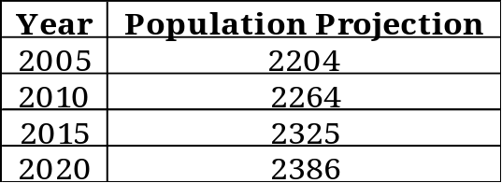
Source: Cape May County Planning Department, November 2001

The County population estimates illustrate that the year round population is expected to remain largely static in the next 20 years.

Population by Age Cohort

Table D-3 – Population by Age Cohort – Year 2000

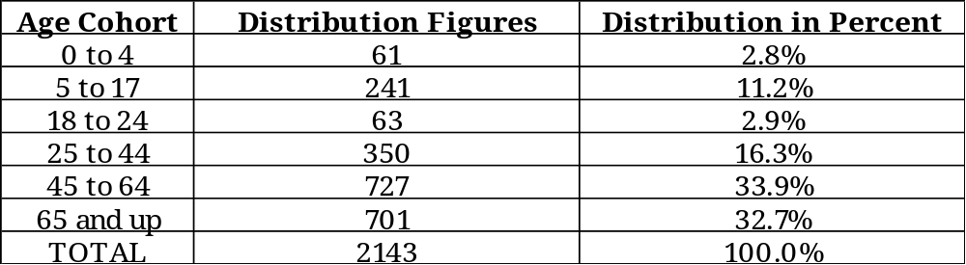
Source: US Bureau of Census

The median age in Avalon is 56 years old, as illustrated by the 33.9% of individuals in the 45 to 64 age category. The next highest category is the 65 and up age cohort with 32.7% of the total.

Households and Families

Table D-4 – Households and Families

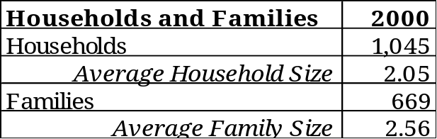
Source: US Bureau of Census

The steady nature of Avalon’s population can be partially attributed to a relatively low household size.

Housing Units by Tenure and Vacancy Status by Type

Table D-5 – Housing Units by Tenure and Vacancy Status

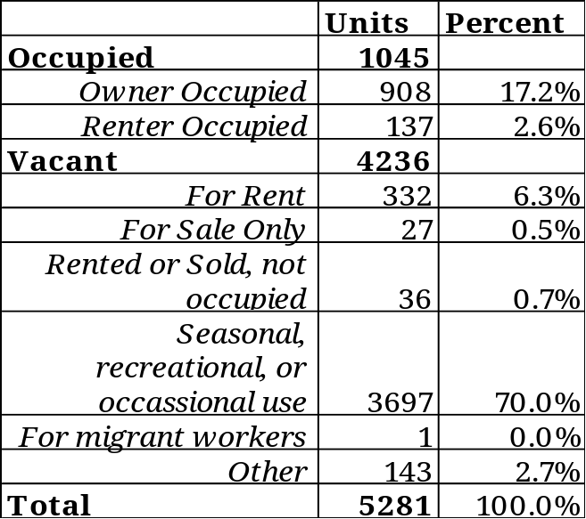
Source: US Bureau of Census

The total number of housing units in Avalon is 5,281 and of that figure there are 1,045 occupied units and 4,236 vacant units. The occupied units account for only 19.8% of the total units, while the vacant units account for the remainder or 80.2%. It is evident that most of the units are seasonal in nature and account for the population swell in the summer months.

Housing Units

Table D-6 – Authorized Dwelling Units 1990 to 2000

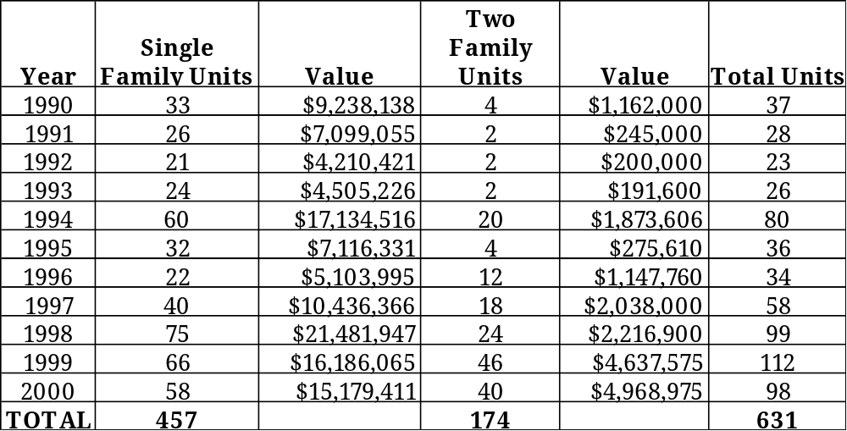Source: US Bureau of Census

Avalon is being steadily redeveloped through demolitions and reconstruction. There is an element of the redevelopment, which consists of infill and demolition of dwellings located on more than one lot, or conversions of single family units or commercial properties to two-family dwellings. The development of single family units had been fairly steady of 20 to 40 units per year with higher exceptions in 1994, 1998, 1999 and 2000. In 1992 the single-family development consisted of a low of 21 units while the high in 1998 consisted of 75 units. The development of two-family dwellings has greatly increased from lows of 2 units per year in 1991, 1992, and 1993, to a high of 46 units in 1999.

Land Use Element
The land use plan element is required to show the existing location, extent, and intensity of development of land to be used in the future for varying types of purposes, including residential, commercial, recreational, educational, and other private and public purposes. The land use element is to relate to the existing and proposed zone plan and zone ordinance.

Avalon can be classified as a completely developed small stable village with a population of under 10,000 persons. The Land Use Plan targets specific plans for particular portions of the community to retain commercial uses and implement design improvements.

Existing Land Use

Avalon Borough is largely developed and is being redeveloped in all existing residential and commercial zones.

Table LU1 – Lot Count by Zone

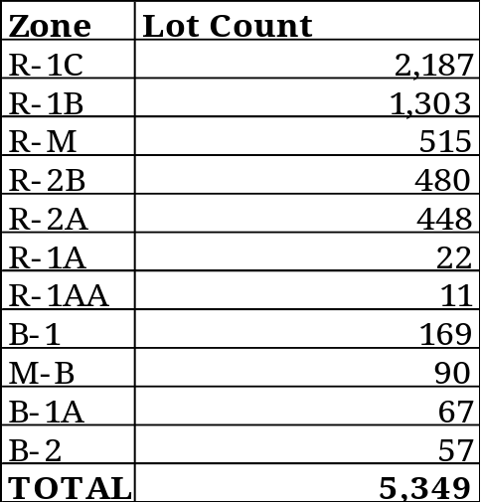

The total number of lots, including substandard lots, is 5,349. Substandard lots are those lots shown on the tax map, which do not conform to the requirements of the zone. A brief analysis determined that the substandard lots are not a significant portion of the lots counted. In some zones, there are no substandard lots, such as the R-1A and R-1AA Zones. Residential zones contain 4,966 lots or 93% of the units in the Borough. Commercial Zones encompass 383 parcels or 7% of units. The commercial zones, which include the B-1, B-1A, B-2, M-B, and R-M permit single family, two-family, and/ or multi-family residential uses in addition to the commercial uses.

Table LU2 – Parcel Counts with Breakdown by Lot Frontage

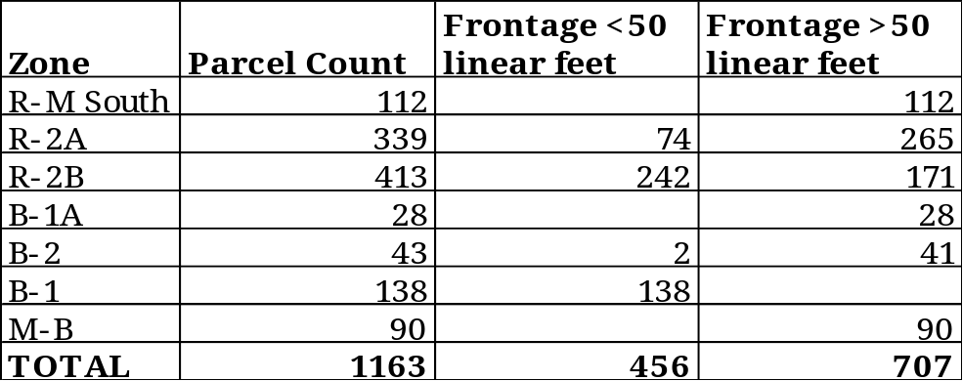

The parcel counts of specific zones have been further examined because these areas are likely to experience the most redevelopment at the highest densities.
One of the most significant increases in units could occur in the B-1 Zone if second floor residential is permitted conditionally. There are 138 parcels having fifty (50) linear feet of frontage, which would permit 138 second floor residential units. One of the other significant areas is the R-M Zone South where 112 two-family units or 224 units could be erected or redeveloped. The hotels and condominiums alone, currently located in a four-block area could result in 80 two-family units or 160 units.

Table LU3 – Percentage of Land Area Within Each Zone District

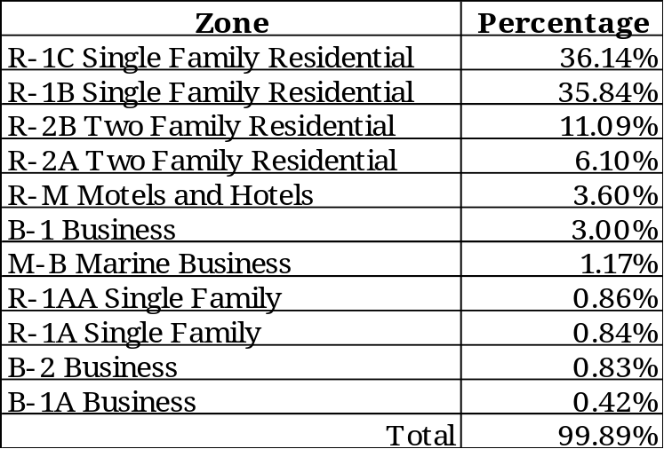
Source: Kona & Associates
Notes: 1. The percent land area calculation is based upon the existing zoning map and does not include non-conforming uses.
2. The P-U Public Use and P-C Public Conservation Districts are excluded from the calculation of percent land area for Table LU3.

Table LU3 illustrates that most land in the Borough is residential in nature. What this table does not illustrate is that single family, two family, and multi-family residential uses are permitted and developed in most of the commercial zones.

In conclusion, the fact remains that a vast majority of the development in Avalon is residential with a small portion dedicated to commercial uses. The tax assessor has noted that currently the most desirable investment parcels are those which can be developed with two-family uses. Table D-6 reinforces that two-family dwelling development is increasing with the possibility that a large portion of the commercially zoned land could become two-family residential uses due to the values of land.

Residential
The existing residential zones do not require any land use amendments or changes. The Planning Board has identified the Residential Districts and districts containing single family and two-family residential development in the community in need of review, relating specifically to the bulk of structures. The Housing Element will address the concerns of the Board in relationship to the bulk of structures.

At the time of the last Master Plan in 1979, motels and hotels were included in the residential developed land category. The Zoning Ordinance in the list of permitted uses in the R-M Zone permits single-family, two-family, multi-family dwellings, and townhouses. The residential uses listed are also permitted in the B-1A and B-2 Zones.

Commercial

R-M Motels and Hotels Zone
A portion of the zone is located at the south end of town between 78th Street and 80th Street from the Beach to Ocean Drive; and from 79th Street to 80th Street from Ocean Drive to the Bay. The other portion of the zone is located in the north end of town between 12th Street and 18th Streets along Ocean Drive and on the west side of Ocean Drive between 6th and 9th Streets.

The permitted uses in the R-M Zone include single-family dwellings, two-family dwellings, essential services, public parks, public playgrounds and recreational areas operated by membership organizations for the benefit of their members or for the general public and not for gain, and Municipal buildings. Conditional uses include churches, public libraries, hospitals, nursing homes, motels and hotels, multi-family dwellings, townhouses, public and private schools, wireless telecommunication towers and antennas. Private garages, tennis courts, swimming pools, off-street parking, signs, home occupations and private docks are permitted as accessory uses.

R-M Zone South (Area #1)
The Planning Board has identified the R-M Zone located in the southern portion of the Borough as an area in need of a specific land use plan. Recently in that area, there has been a trend to remove commercial structures and replace them with two-family dwellings. The Planning Board is concerned that residential units including single-family, two-family, multi-family, and townhouses could replace the commercial uses, such as hotels, motels and restaurants currently located there. The Planning Board believes that proposing incentives for redevelopment including density and height bonuses for commercial redevelopment of existing hotels and restaurants may assist in retention of commercial uses.

Figure 2 – Existing Land Use Plan R-M Zone South (Area #1)

B-1 Business Zone (Area #2)
The B-1 Business District is located from 20th Street to 33rd Street along Dune Drive and extends to the east side of Ocean Drive from 20th to 22nd Streets. The B-1 Business District permits retail stores and shops, personal service shops, banks, theaters, offices, restaurants, community services, retail or light wholesale uses, and municipal buildings. Conditional uses include commercial tennis courts, churches, public libraries, and public and/or private schools. Currently, off-street parking, signs, second floor residential, and home occupations are permitted accessory uses.

The board believes that any review of the uses in the B-1 Zone include a review of recreational amusements and set standards for uses and structures, including miniature golf courses and mazes.

There has been a trend to create larger commercial buildings consisting of office and retail stores and shops, and second story residential, portions of which are leased or sold. The existing zoning ordinance does not permit multiple uses on one lot. The Planning Board encourages the amendment of that provision for the commercial zones. In addition, accessory uses are uses which are incidental to the principal use of the land or building, located on the same lot with the principal use. When second floor residential is permitted as an accessory use, typically those uses are accessory to an office or business located on the premises, and the residential use is used by the owner or operator. Existing market trends generally do not create situations where owners and operators reside on the premises. The Planning Board seeks to encourage redevelopment activity in the B-1 Zone and create a more dynamic streetscape by encouraging second floor residential uses as a conditional use.

B-1A Business Zone (Area #3)
The B-1A Business District is located on the east side of Ocean Drive from 22nd to 29th Streets. The B-1A Business District permits single family dwellings, two-family dwellings, essential services, retail stores and shops, personal service shops, banks, theaters, offices, restaurants, community services, retail or light wholesale uses, convenience stores and supermarkets, and municipal buildings. Conditional uses include commercial tennis courts, churches, public libraries, public and private schools, and public garages and filling stations. Private garages, private tennis courts, swimming pools, off-street parking, signs, and home occupations are permitted accessory uses.

The intent of the B-1A Zone is to create a community wide commercial area which provides services such as automobile service stations and retail convenience stores and supermarkets. The Planning Board is concerned that these community wide uses are being lost to permitted residential development. In order to provide a consistent retail sales and service oriented streetscape on the east side of Ocean Drive in the B-1A Zone, the Board seeks incentives to encourage redevelopment of existing commercial properties and discourage single family and two family dwellings. The Board is evaluating permitting second story residential uses. Unfortunately, all uses in the district are not suited to second floor residential, such as gas stations. Unlike the B-1 Zone, this area contains larger expanses of areas which are not commercial storefronts in the form of residences and parking lots. The addition of second story residential uses in this zone may or may not have the intended effect of encouraging pedestrian activity in this smaller commercial zone. Encouraging mixed uses, such as convenience stores with automobile filling stations could assist retention of the commercial uses.

The properties located on the southeast corner of 29th Street and Ocean Drive and also known as block 29.04, lots 65.04, 65.05, 65.06, 66.01, 66.02, and 66.03 are currently zoned R-1B and are commercial in nature. It is recommended that the property be zoned B-1A in order to be consistent with the B-1A Zone located north of the parcels.

Figure 3 – Existing Land Use Plan B-1 Business Zone (Area #2) and B-1A Business Zone (Area # 3)

B-2 Business Zone
A portion of the B-2 Business District is located along Ocean Drive from 64th Street to 69th Street and will be called B-2 Zone West. Another small B-2 Zone is located on Ocean Drive between 78th and 79th Streets. The southernmost B-2 Zone has recently been redeveloped with three two-family dwelling units. Single family dwellings, two family dwellings, retail stores and shops, personal service shops, banks, theaters, offices, restaurants, community services, retail or light wholesale uses, and municipal buildings are permitted uses. Permitted conditional uses include commercial tennis courts, churches, public libraries, and public or private schools. Accessory uses include private garages, signs, swimming pools, off-street parking, private tennis courts, home occupations, and second floor residential.

B-2 Zone West (Area #4)
This area was intended to provide a commercial node for the surrounding residential development, but has historically developed with mostly residential and few commercial uses. In addition, accessory uses are uses which are incidental to the principal use of the land or building, located on the same lot with the principal use. When second floor residential is permitted as an accessory use typically those uses are accessory to an office or business located on the premises and the residential use is used by the owner or operator. Existing market trends generally do not create situations where owners and operators reside on the premises. The Planning Board seeks to maintain the existing development patterns, rather than create awkward non-conformities. This can be accomplished by permitting second floor residential uses as a conditional use, not an accessory use.

A parcel located on the eastside of block 78.05, lots 1 and 2 on Ocean Drive is zoned B-2, but has recently been redeveloped with three two-family dwellings. The parcel should be rezoned to R-2A in order to be consistent with the R-2A Zone directly to the west.

Figure 4 – Existing Land Use Plan B-2 Zone West (Area #4)

Community Design Plan
The Community Design Plan Element is a subplan of the Land Use Element and is intended to provide building and development design standards. Good project design is important because new development and redevelopment should be harmonious in appearance.

Business Zones (B-1, B-1A, and B-2)

Center Design Guidelines
The Planning Board intends to create Center Design Guidelines for the Site Plan and Subdivision Ordinance for the B-1 Zone. These Center Design Guidelines will further enhance the Dune Drive Street Improvement Project undertaken by the Mayor and Council at the Planning and Zoning Board levels. The Center Design Guidelines will provide continuity of design by reinforcing the streetscape, hardscape, and landscape improvements once designed. In addition, the Board intends to review the sign regulations to further enhance the overall image of the Central Business District and other business districts as one enters and passes through.

Streetscape includes the building facades, attached signs and lighting. Hardscape is generally understood as the sidewalks, driveways, and parking lot materials. Landscaping includes street trees, planting strips, hedges, street furniture, benches, trash receptacles, recyclable receptacles, mailboxes, and public telephones. Both external and internal lighting, roof signs and window clutter would be addressed in the sign ordinance.

Humanism, Pedestrianism, and Streetscape
The relationship between the dimensions of the human form and the proportion of the spaces that they use defines human scale. Places respecting human scale are visually interesting and are more comfortable. Pedestrian linkages such as sidewalks encourage pedestrianism and provide opportunities to meet and interact. A strong network of sidewalks and public promenades services Avalon.
- Enhancing the pedestrian experience includes appropriately sized and located crosswalks and depressed curbs.
- Gr0und texture is an important element of pedestrian amenity and increases values. Methods of creating texture include introducing pavers or applying creative decorative techniques to concrete.
- Sidewalk width is also an important element. For example a four and half foot wide sidewalk is more comfortable for two people walking side by side.
- In commercial areas it is preferable to allow buildings to sit directly on the edge of the sidewalk, unless outdoor displays are encouraged, which generally require a setback of at least four (4) feet. It is preferable that the sidewalk be on grade with the ground floor level of along retail frontages, but offices and other facilities may be raised above sidewalk level.
- Complementary pedestrian amenities include light poles, benches, planters, waste receptacles, and ash cans. Light poles, ranging from nine to twelve feet in height are in human scale. Careful consideration of the lighting plan is important because too much lighting can drastically effect the character of an area.
- Quality signs greatly enhance the pedestrian experience. Signs can be of a small scale and attached to or hang from the building façade, painted on the inside of a window, or printed on an awning. Due to the mixed nature of Dune Drive especially, both larger signs and smaller signs are encouraged to provide information to motorists as well as pedestrians.

Open Space and Core Community Greens
Open spaces include community greens and commons as well as peripheral spaces, but for this discussion the Planning Board will focus on the core community green located on Dune Drive. Avalon contains several outdoor gathering places including the beach at the 21st Pavilion, the beach around 30th Street near the Community Hall, and the “circle” located at the intersection of 21st Street and Dune Drive. In this context, the “circle” is considered the “community green” because it is used especially for holiday parades and memorial ceremonies, which begin at the Borough Hall and end at 21st Street. Historically the circle was the gateway entrance to Avalon, when the Avalon Boulevard from Middle Township crossed over into Avalon on 21st Street. Typically central greens or commons are larger and act as a foundation for the social life of the community, including bazaars, holiday displays, and hubs of community activity. The optimal size for a community green is 200 square feet per housing unit in the area it serves. Parking located around the green can absorb large numbers of parked vehicles reducing the need for off-street parking lots and enhancing pedestrian activity on the street. Typically the community green contains some vertical element such as a larger community building or focal point. In this instance a flagpole is the vertical element.

Mixed and Multiple Uses
Small communities must have mixed and multiple uses, mixes of housing types and costs, and affordable housing. Mixed uses come in many combinations such as, retail on the ground level with housing above and retail on the ground level with offices above. Avalon is witnessing a trend of conversion of office space to residential space above both ground floor retail and office space. Housing is one of the most appropriate uses on the second floor. Each housing unit should have a minimum of 36 square feet of exterior balcony space and have exterior entrances separated from the commercial uses. Affordable housing dispersed in the mixed-use core area would provide needed low and moderate income housing space in the community.

Design Vocabulary
Surveying the community or committee through workshops will aid in the preparation of a design vocabulary for the central business district. A distinctive unity can be retrofitted to an existing place by adopting guidelines for the following:
Roof types and materials – Specifically this should detail roof pitches, shapes, forms, and acceptable materials.
Façade treatments and materials – Wall materials should be those used with success in the past on buildings identified by the committee.
Doors and Windows – The location, orientation, and proportion of door and window openings should include consideration for rhythm, texture, articulation, modulation, and scale.
Streetscape Elements – Streetscape elements include lighting, trash receptacles, recyclable receptacles, ash cans, and benches. These elements will be determined once the streetscape design is completed.

The Planning Board asserts again that in no way are these design guidelines framed to forestall creativity or originality. The design guidelines are intended only to facilitate and foster creativity in the development community.

Maintenance
Property maintenance for commercial, rental, two-family residential, and multi-family residential properties is a critical aspect of any ordinance because visible deterioration negatively impacts the community. Property maintenance programs should include the following:
- Inspection;
- Sufficient time to repair or maintain once cited;
- Processing completed work in a timely manner;
- Pressing legal action where required; and
- Withholding occupancy permits.

Housing Plan Element

The Housing Plan Element should address residential standards and proposals for the construction and improvement of housing. A housing plan is required in order for the governing body to amend the zoning ordinance relating to the nature and extent of the uses of land and of buildings and structures thereon.

Table HP1 – Number of Demolitions by Year

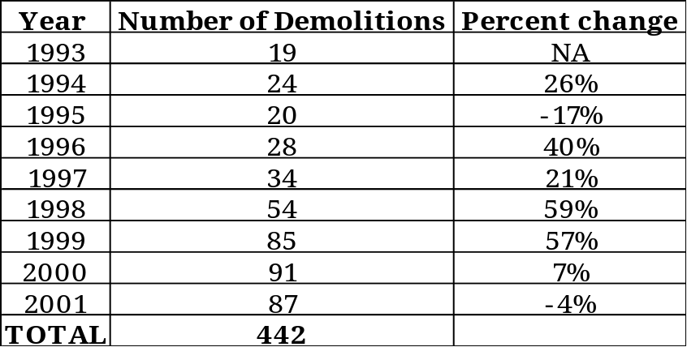
Source: Avalon Construction Office.

The community has witnessed the steady redevelopment of existing residential and commercial structures, through demolition and renovation with the exception of the years 1995 and 2001. The total number of demolitions in the period between 1993 and 2001 is 442, or approximately 8% of the total dwelling units in the community. During 1999 and 2000, there were 85 and 91 demolitions respectively, or 176 total (42% of the total). These demolitions result in the construction of at least one, and up to four new residential units. This trend for demolition and reconstruction results in infill development.

Size of Residential Structures in Square Feet
The assessor’s office analyzed between nine to eleven (9-11) dwelling units in the R-1B, R-1C, R-2A and R-2B Zones, which were originally constructed from 1965 to 1970 and redeveloped or reconstructed from 1995 to 2000. (See Appendix A – Square Foot Comparison)

Table HP2 – Average Square Foot Comparison

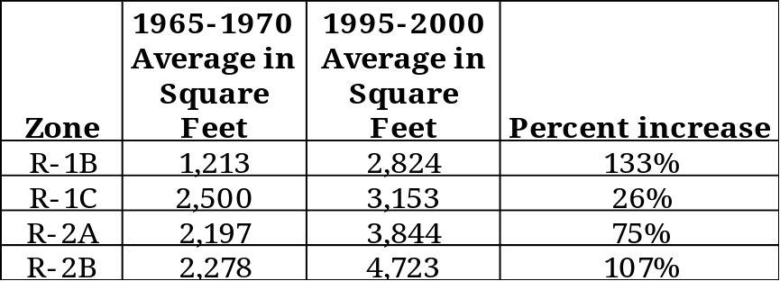
Source: Avalon Tax Assessor’s Office

The area with the largest percent increase in the size is the R-1B Single Family Residential Zone located in the southern portion of the community at 133%. The next highest percent increase was 107% for the R-2B Single Family and Two-Family Zone located in the lagoon area between 2oth and 25th streets from the west side of Ocean Drive west to 7th Avenue. It should be noted that in the R-1C Zone, the properties were all located in the “beachblock”, which are highly desirable properties. The “beachblock” in this portion of the community is generally described as the area east of Avalon Avenue from 7th Street to 32nd Street and the area east of First Avenue from 32nd Street to 40th Street. The increase was only 26% in this area however the single-family homes constructed between 1965 and 1970 had square footages averaging 2,500 square feet the highest average for that time period. The R-2A Single Family and Two-Family Zone increased by 75%.

Density
Density is defined by the MLUL as the number of dwelling units per gross area of land to be developed.

Table HP3 – Density as Permitted in Existing Zoning Districts

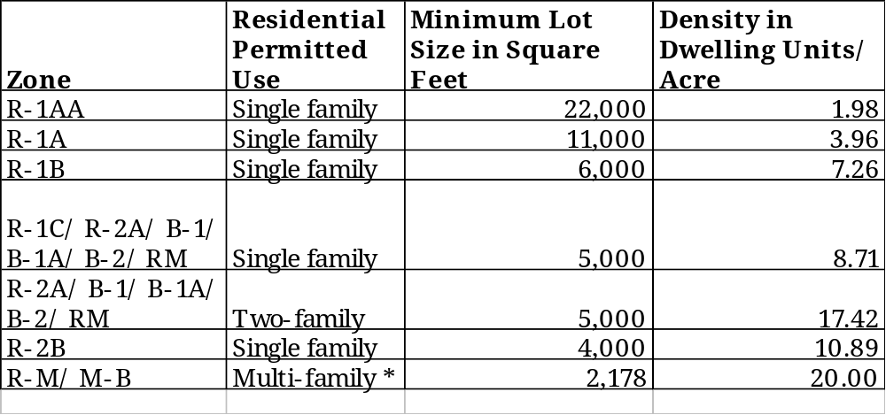
* Note: The multi-family conditional use requirements set forth a minimum parcel size of 2,178 feet not a minimum lot size.

The densities in Avalon vary a great deal from 1.98 dwelling units per acre in the R-1AA Zone up to 20 units per acre in the R-M and M-B Zones. The Planning Board has identified key issues related to density including population, traffic, and parking as concerns of this reexamination report.

Floor Area Ratio
Tables HP4 through HP10 consist of figures obtained from the tax assessment records. They do not reflect the standard requirements of the definition for Floor Area Ratio. Floor Area Ratio (FAR) is defined by the MLUL as “the sum of the areas of all the floors of buildings or structures compared to the total area of the site.” This includes attached and detached sheds, garages, cabanas and other accessory structures by definition. The tax assessment records indicate habitable building size in square feet only, excluding garages and accessory structures. The tax assessor’s office was able to provide the square footage of garages, which are part of the dwelling, but not detached structures. The data provided determines an appropriate FAR figure to be used for residential uses in the Zoning Ordinance.

Specifically, the tax assessor’s report provided by the assessor’s office contained 667 line items, consisting of one and two-family dwellings constructed between January 1990 and October 25, 2001 in zones where residential uses are principal permitted uses. Of those 667 line items, the FAR of 75 line items was evaluated. Those 75 line items were chosen based upon the large size of the building square footage in relationship to the lot square footage. The tables are examples of dwelling units with the highest square footages in the zone, to illustrate the highest potential FAR figures for the purposes of this exercise. Of the 75 line items evaluated 22 buildings exceed a FAR of 0.75.

Table HP4 – R-1A Zone Floor Area Ratios (FAR)

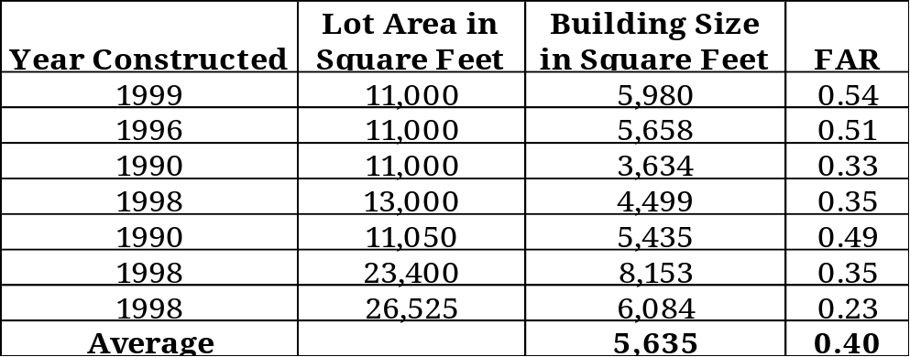

Table HP5 – R-1B Zone Floor Area Ratios (FAR)

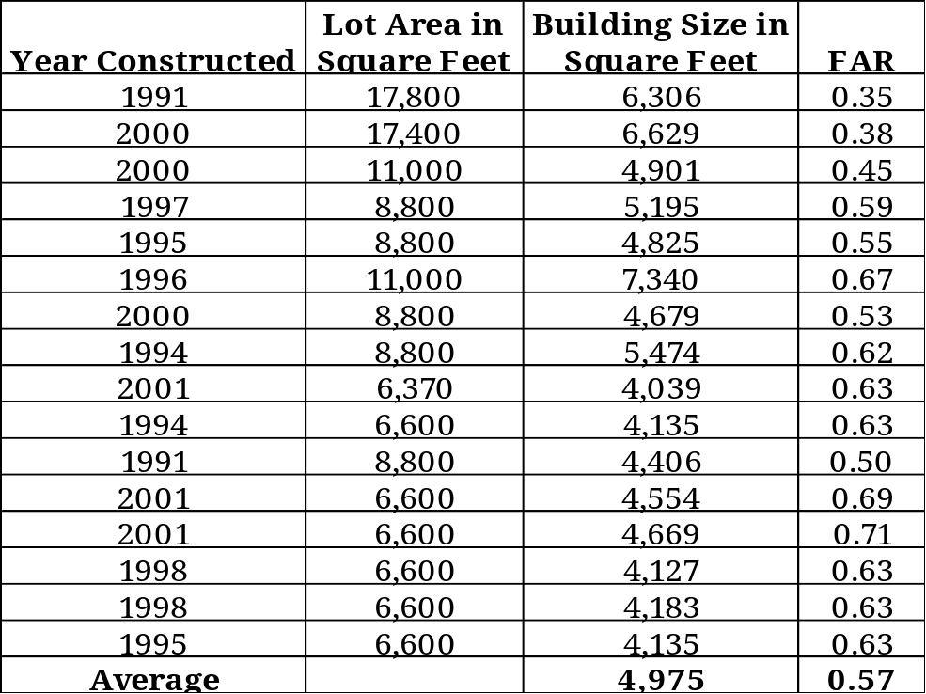

The average FAR in the R-1A and R-1B Zones are fairly low, 0.40 and 0.57, respectively. The Planning Board has not identified density of units, population, and vehicles as an area of concern and the FAR figures confirm that. If rental occupancy rates were to change in the area, any deficiencies in the amount of off-street parking would become a concern. The square footage figure of 4,975 in the R-1B Zone is approximately 2200 square feet larger than the average for the zone shown in Table HP2.

Table HP6 – R-1C Zone Floor Area Ratios (FAR)

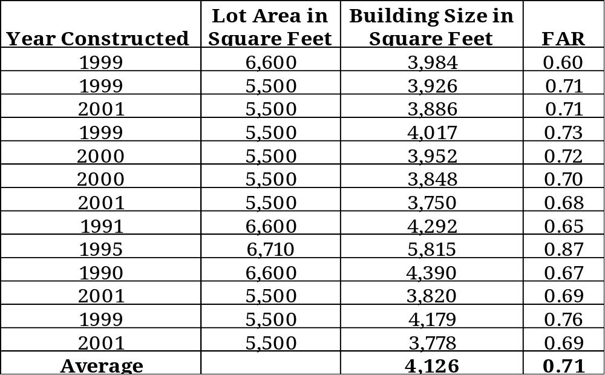

Table HP6 illustrates an average FAR of 0.71 in the R-1C Zone. One structure stands out as having a FAR of 0.87. The Planning Board has identified portions of this predominately single family housing area as problematic. Density issues, including the availability of on-street and off-street parking and population swells along the beach block, have increasingly become issues for the zone.

Table HP7 – R-2A Zone Floor Area Ratios (FAR)

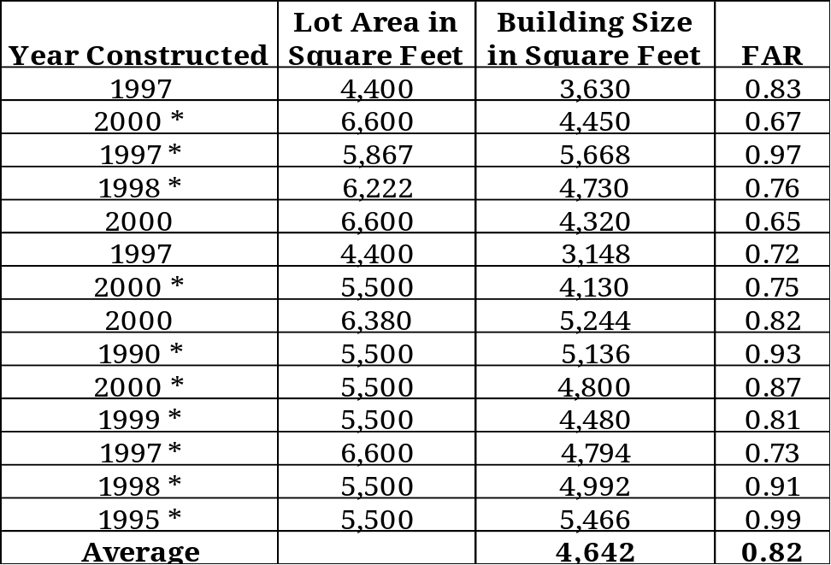
* Note: The asterisk shown after the year, indicates two-family dwelling units.

The average FAR in the R-2A Zone is 0.82. A total of nine (9) out of the fourteen (14) structures have a FAR in excess of 0.75. The Planning Board has identified the R-2A Zone as an area of great concern, for a number of reasons. The R-2A Zone is located on the west side of Ocean Drive from 19th Street to 42nd Street, and also between Ocean Drive and Dune Drive from 30th Street to 35th Street, and lastly between Ocean Drive and Fourth Avenue between 39th and 42nd Street. These areas of town are notoriously congested due to regional and local traffic on Ocean Drive. In addition, on-street and off-street parking demand becomes an issue regularly due to the residential uses, as well as commercial uses located nearby. The population in these areas swells tremendously during the summer months, especially on weekends.

Table HP8 – R-2B Zone Floor Area Ratios (FAR)

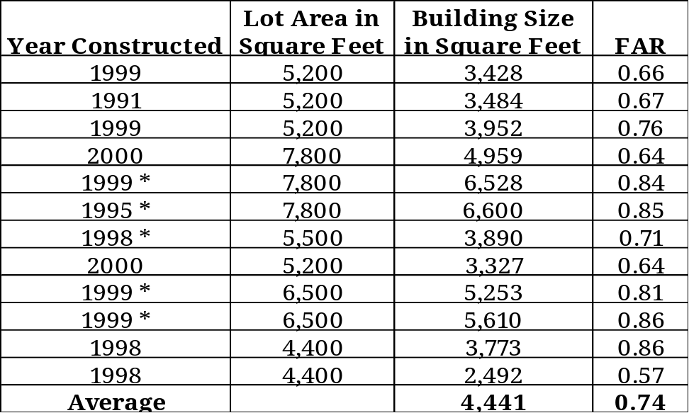
* Note: The asterisk shown after the year, indicates two-family dwelling units.

The R-2B Zone average FAR is 0.74. Four (4) of the two-family structures exceed a FAR of 0.75 and two (2) of the single family structures exceed a FAR of 0.75. The Planning Board has identified density issues, including availability of on-street and off-street parking and population swells as a concern in this area.

Table HP9 – B-1A Zone Floor Area Ratios (FAR)

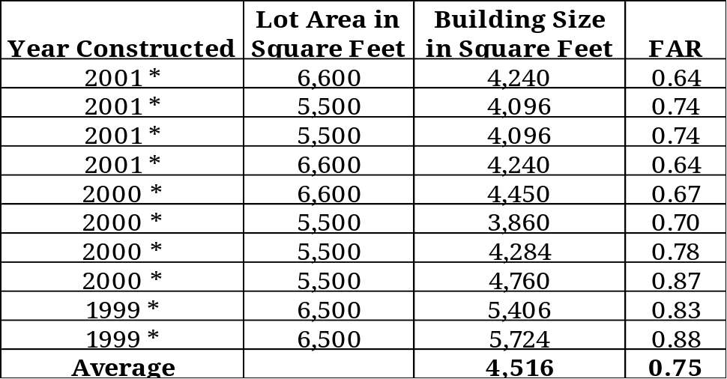
* Note: The asterisk shown after the year, indicates two-family dwelling units.

The average FAR in the B-1A Zone, where all the residential construction surveyed was two-family structures is 0.75. Four (4) of the properties surveyed exceed a FAR of 0.75.

Table HP10 – B-2 Zone Floor Area Ratios (FAR)

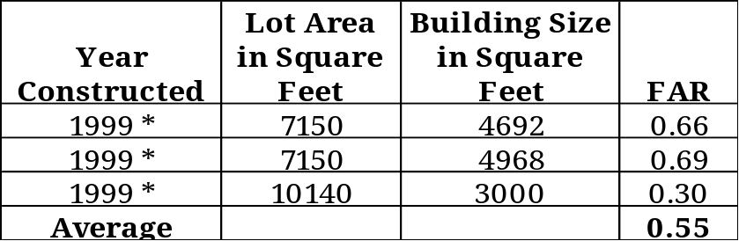
* Note: The asterisk shown after the year, indicates two-family dwelling units.

Table HP10 illustrates that the three (3) residential units surveyed constructed in the B-2 Zone do not exceed a FAR of 0.69.

The infill development which is occurring is considerably larger in square footage than most of the existing housing stock, resulting in reduced light and air, increased runoff, and increased parking demand and negative perceptions about the mass and visual impact on the community.

In order to continue to accommodate growth and redevelopment while providing controls, the Planning Board considers the addition of a maximum Floor Area Ratio for one and two-family residential structures a worthy solution. Communities throughout New Jersey are utilizing FAR maximums to limit the mass of structures and the structures’ impact upon the street and surrounding properties. A FAR between 0.70 and 0.75 will continue to encourage redevelopment of existing structures while balancing the need to control building mass.

Mass and Scale
The Planning Board has identified the mass and scale of structures as one of the key issues related to any proposed Zoning Ordinance Amendments. Mass in this context refers to a massive size or effect, such that the effect is imposing and large in comparison to what is considered typical. Building mass is the volumetric shape of a structure including sides, and roofs and the size of the base, or footprint. Scale is the relationship of the built environment to the human frame. Buildings and features relate to the pedestrian through elements such as windows, doors, architectural details, and treatment of the ground plane.

Flood Control
The National Flood Insurance Act of 1968 administered by the Federal Emergency Management Agency (FEMA) an agency of the Housing and Urban Development (HUD) provides flood insurance protection to property owners in flood prone areas. All communities, which are part of the program must adopt and enforce flood plain management regulations, which are consistent with the Federal Government’s guidelines. These regulations take precedence over any less restrictive local laws, ordinances, or codes. Avalon has determined that buildings be constructed by practices that minimize flood damage. Avalon requires that structures be elevated so that they are at or above base flood elevation, unless they are appropriately floodproofed. Specifically, all new construction and substantial improvements must be constructed with electrical, heating, ventilation, plumbing, and air conditioning equipment and other service facilities that are located so as to prevent water from entering or accumulating within the components during conditions of flooding.

Building Height
Building height is defined by the existing Zoning Ordinance as the vertical dimension of a building measured from the elevation of the established finished floor level as set forth by the Federal Flood Control Act to the highest point of the roof. The Planning Board has identified the definition of “building height” as one of the components of the ordinance requiring review. The existing permitted height in all zones in the Borough is thirty (30) feet.

The Borough of Avalon General Elevation Reference Map consisting of two sheets illustrates that the elevation of the island varies from twelve (12) feet along the beach down to generally five (5) feet along the inland waterway. The intention of the building height definition is to require that all structures in Avalon be at or above base flood elevation or elevation 10.

One of the key issues identified by the Planning Board relates to the mass of structures as it relates to height. The Planning Board has determined that the words finished floor should be removed and that the “top of block foundation” should be added to the definition.

Figure 5 – Borough of Avalon General Elevation Reference Map

Architecture
The Planning Board has identified the lack of architectural details in the design vernacular as an area of great concern. Residential architectural design on the island from the 1960’s to the present has created numerous homes that lack fenestration and detail and are boxy in appearance. The Board is opposed to creating architectural standards and an architectural review board, and prefers to allow architects greater flexibility and creativity with design. Development in the community is typically completed on a lot by lot basis, which would preclude an Architectural Review Board’s input on most projects. The Board determined that architectural details would be passively encouraged through the Zoning Ordinance for residential structures. The Board seeks to actively encourage architectural detail in the Subdivision and Site Plan Ordinance for commercial structures in the business districts.

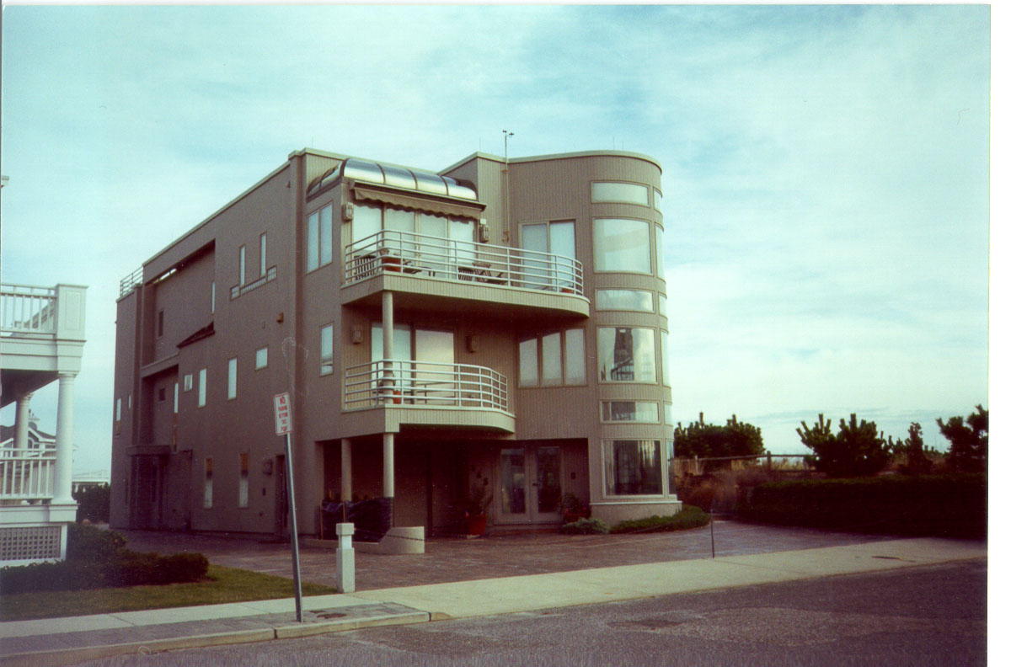
Three story dwelling with flat roof, surrounded by pavement, limited plantings, and one continuous curbcut.

The Planning Board seeks to encourage the following architectural features in all residential development. Designers should seek rhythm and modulation for door and window placement. Porches, covered patios, and arcades are encouraged in order to provide a relationship to the street in keeping with the architectural design elements of the past. Trim may be used to add character to the façade including eaves, corner boards, gable and eave boards, pediments, lintels, sills, belt courses, and balustrades. Other decorative elements include gables, bays, dormers, chimneys, and cupolas.
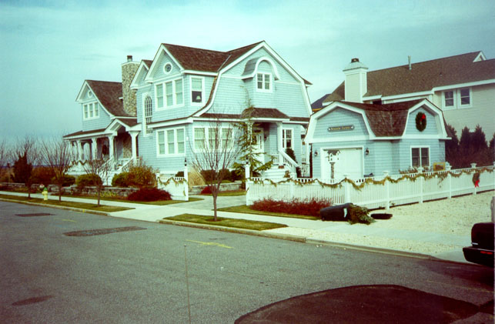
A new home constructed with architectural detailing including covered porches, chimney, decorative stairs, changing roof pitches, landscape plantings, and detached garage.

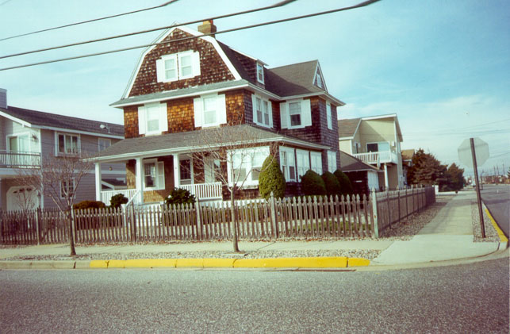
An older home with covered porch, decorative stair, and varied roof pitches.

Height Exceptions
Historically, homes in Avalon contained decorative roof elements. In order to promote architectural creativity and variation in design, the Planning Board encourages Decorative Features. Decorative Features, which are not inhabited or habitable, including false fronts, roof parapets, falsework, cornices, cupolas, finials, spires, weather vanes and other decorative features are encouraged to exceed the building height limitation by less than 10% or three (3) feet. Variances are required in order to accommodate any height in excess of the required maximum.

Building Coverage
Building coverage is typically defined as the horizontal area measured along the outside perimeter of the exterior walls of the ground floor for all principal and accessory buildings on a lot, divided by the entire area of the lot. The existing permitted building coverage is 30% and currently includes swimming pools. The Board is hesitant to reduce the permitted building coverage due to the extent of non-conforming structures that would be created. The Board seeks to encourage architectural details, such as roofed open porches, chimneys, and open and covered stairs. The permitted building coverage would continue to be 30%. Building coverage would be distributed to permit 27% of coverage for habitable building area and accessory building area and 3% for architectural details including, but not limited to, roofed open porches, chimneys, stairs and etc. Swimming pools would no longer be considered “building coverage”, but would be considered “impervious cover”, resulting in the creation of fewer non conforming structures.

The Board is concerned that a great number of cantilevered second and third stories are being created. Under no circumstances are cantilevers to extend into the required yard setbacks of any zone.

Roof Pitch
Many of the roof pitches of new single family and two family dwellings in Avalon tend to be flat or at an angle of two (2) feet of vertical rise in twelve (12) feet of horizontal run (2:12). Roof pitches greater than 2:12 are more consistent with the historical housing stock, generate visual interest and prohibit massive third floors, which greatly impact the human scale. The Planning Board has generated comments ranging from requiring roof pitches of a minimum of 8:12 down to 4:12. In order to enhance architectural creativity, the Zoning Ordinance may be amended to require “roof plans” for the Zoning Officer to review. Provisions of the roof pitch minimums could permit 20% of the roof to be flat to allow details such as a widow’s walk, with an average roof pitch of 4:12.

No such roof pitch requirements are encouraged for multi family, townhouse, hotel and motel, retail, and office buildings. The maximum permitted height in the community of thirty (30) feet precludes these types of buildings from accommodating the minimum roof pitch requirements.

Third Story
The Planning Board has identified a concern that third stories have become massive in scale and are perceived as imposing from the street. In addition, dwellings are being constructed which are three story flat roofed monolithic structures, which lack appropriate fenestration and detail and present blank facades that are three stories high. In order to provide a reduction in building mass it has been suggested that the total area of the third floor be no greater than 66% of the second floor. In addition, as an alternative, stepping back the third floor equal to the required front building setback, for the zone, would also reduce the scale and mass at street level.

The Planning Board has reviewed the issue further and believes that the FAR will inhibit the perceived mass of the third floor. The Board seeks to further underscore that the issue may be reviewed again if monoliths are constructed.

Garages
In some areas of town, garages and driveways dominate the streetscape and the front yards of single family and two family dwellings alike. Limited off-street parking and the lack of sufficient parking standards exacerbate the problem. The Board has discussed encouraging private garages in the rear yard through a lot coverage bonus increasing off-street parking. Encouraging off-street parking up the side yard is something that the Board is very interested in promoting. Increasing side yard setbacks in some zones to ten feet and encouraging driveways in side yards would increase off-street parking with or without the detached garage bonus.

Decks
Widow’s walks are known as a flat roofed deck or raised observation platform sometimes having a view of the sea, situated on the roof of a house and enclosed by a balustrade or railing. They are part of romantic notions we all have about the sea and days past and provide architectural detail. Unfortunately, widow’s walks have given way to decks perched precariously on flat and peaked roofs added as an afterthought. The Planning Board has identified these decks as contributing to the mass and scale problems. The Planning Board proposes to limit outdoor decks so that the floor of an outside deck shall be no higher than the floor of highest habitable floor in any structure. True widow’s walks with flat area included as part of the structure of the roof may be permitted, provided they meet the roof pitch provisions.

Yard Setbacks
Lot consolidations, creating oversized lots and massive structures has increased perceptibly in the R-1B Zone in the southern portion of the community. Individuals are purchasing two 60 by 110 feet lots and constructing one larger home on two lots. All yard setbacks remain the same, as though there are two homes on two lots.

In the R-1B Zone the front yard setback is fifteen (15) feet, the rear yard setback is twenty-five (25) feet and the total side yard setback is twenty (20) feet with a minimum side yard of eight (8) feet. The Board has identified that these large homes reduce light and air on the street. It is standard zoning practice that front yard setbacks remain consistent, because variation of the setback obstructs views and creates disharmony along the streetscape. Returning to the 120 by 110 foot lot example, if two homes were built on the lots, there would be a total of forty (40) feet side yard setbacks. But if one home is constructed on the lot the total side yard setback for both lots is twenty (20) feet. In order to preserve light and air, where a parcel in any given zone exceeds the minimum lot frontage requirements of the zone, by 25% or more the minimum and total side yard areas should be increased proportionally with the lot frontage. To return to the example where the lot frontage exceeds the required width by 100% then the side yard setbacks shall increase by 100% to 40 feet. This equation equals what the setbacks would be if two homes were constructed on two lots without reducing buildable area.

The equation would be as follows:
X x Percent That Lot Exceeds Minimum Requirements of Zone = Y
Where X = Required Side Yard Setback (Minimum and Minimum Total)
And Y = The Additional Required Side Yard Setback for Property

Bulkhead/ Mean High Water Line
The Board proposes to create rear yard setbacks that protect and enhance the natural environment while creating a consistent appearance along the watercourse. The Board also seeks to protect views from the parcels as well as along the watercourse.

Currently, the Zoning Ordinance requires that the rear yard setback along the inland waterways be taken from the rear lot line, which can sometimes be located in the waterway. In the Lagoons, section of the Borough, a “bulkhead line” was established at the time of subdivision and the rear yard setback has consistently been established to begin at the bulkhead. There are many areas of town where there is no constructed bulkhead and the uplands begin where the waterway ends, at the “mean high water line”. The “mean high water line” is a commonly surveyed line for waterfront properties.

The Board proposes to measure the rear yard setback from the front lot line or street line. For interior bay front lots the front lot line is the line parallel to the street line. For lots where the distance from the street line to the bulkhead line or mean high water line is one hundred and ten (110) feet or less, the rear setback shall be eighty-five feet from the front property line, provided that a minimum of five (5) feet is maintained from the bulkhead line or mean high water line. In no case shall the rear yard setback on any floor above or including the second floor be less than five (5) feet. The rear yard setback on the first floor can be at zero (bulkhead line or mean high water line) as long as decks do not exceed eighteen (18) inches in height from a setback of five (5) feet. In the alternative, for lots where the distance from the street line to the bulkhead line or mean high water line is greater than one hundred and ten (110) feet, the rear setback shall be twenty-five feet measured at the closest point between the bulkhead line or mean high water line and the street line or front lot line.

It should be noted that where the water line is between the bulkhead line and the upland, the water line shall prevail. In addition, all constructed bulkheads shall be measured from the edge closest to the water to determine the lot depth. Some provision must also be made to state that newly constructed permitted bulkheads replacing old bulkheads shall prevail.

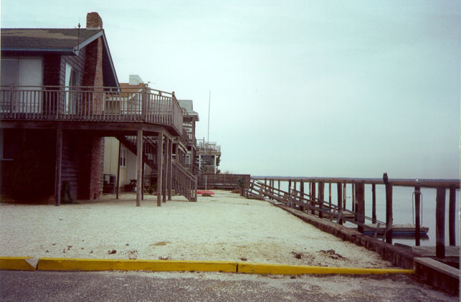
View west from the north end of 5th Avenue illustrating the varying rear yard setbacks along the inland waterway.

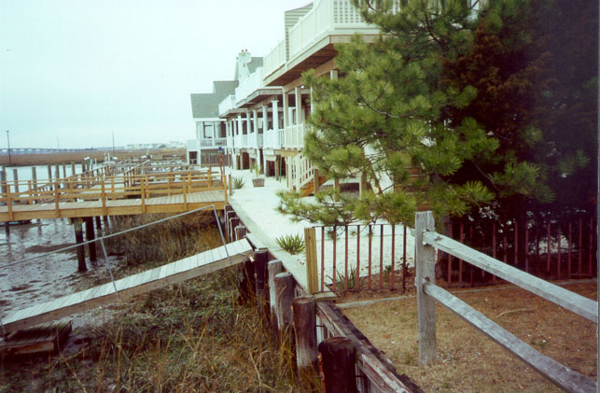
View west from the south end of 5th Avenue. The second story decks in the foreground are approximately five (5) feet from the bulkhead line. Note the building in the background, which is constructed directly atop the bulkhead.

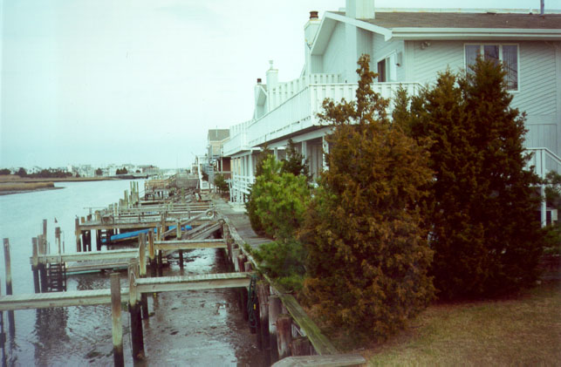
View north from the 30th Street Bridge showing rear decks approximately five (5) feet from the bulkhead. Note the background where a deck is directly atop the bulkhead.

Drainage
Drainage issues have been cited as a common problem in the Borough related to roof drainage as well as drainage of outdoor showers. Roof gutters and downspouts will be specified and can be attached, built-in, or integrated with the trim. Unfortunately, the Zoning Officer in any community is usually not capable of handling drainage issues on their own and must seek assistance from an engineer and/or Construction Official. If an outside professional reviews every application for a zoning permit to insure drainage compliance, this can become costly for the community or the applicant. Some communities solve this problem by placing basic drainage requirements, such as dry wells or infiltration trenches in the code, and requiring that an engineer or surveyor hired by the applicant, certify that the drainage improvements have been installed as required.

Green Space
The Planning Board is concerned that some individual lots in the Borough are being developed without even minimal landscape planting. In order to promote stormwater infiltration and enhance the built environment, the Board desires to require that all lots which are subject to development reserve a portion of the lot for green space and plantings. The plantings could consist of lawn, groundcover, perennials, shrubs, and trees with mulch, if desired. Decorative stone is not included in the minimum green space requirement.

Landscape
Landscape Ordinances promote a desirable visual environment through creative design techniques and good civic design and arrangements; and promote the conservation of open space and valuable natural resources in the Borough; and prevent urban sprawl and degradation of the environment through improper use of the land. Landscape encompasses vegetation both existing and proposed, and other materials such as streetlights and benches. The Board desires to compose a Landscaping Ordinance, which provides standards for redevelopment of larger parcels seeking site plan and subdivision review. In addition, the Board seeks to include landscape requirements in the Zoning Ordinance for redevelopment occurring on a lot by lot basis.

The ordinance would seek to accomplish the following:
- Enhance the front yard;
- Enhance the side and rear yards, including walls, fences and hedges;
- Create formal tree-lined avenues;
- Preserve existing vegetation where possible, through selective clearing and vegetation protection;
- Promote a desirable list of street trees;
- Promote landscaped parking areas, site furnishings, and depressed curbs where appropriate;
- Set aside passive and active recreational open space on larger parcels (if redeveloped);
- Create nuisance and filtered buffers and windbreaks; and
- Create pedestrian spaces.

Zoning Ordinance
The Planning Board, Zoning Board of Adjustment, and Staff has identified several areas of the Zoning Ordinance requiring amendment, including the following:

- Language Interpretation and Definitions
- Establishment of Zone Districts
- Zoning District Regulations
- Permitted, Conditional, and Accessory Uses
- Fences
- Off-Street Parking Requirements
- Curbing and Parking Access Standards
- Signs
- Non-Conforming Buildings, Structures, and Lots
- Conformity of Building Setback Lines
- Administrative Guidelines
- Accessory structure setbacks from property lines and from principal structures

Circulation Plan Element
The Circulation Plan Element describes how vehicles, pedestrians, bicycles, and transit vehicles circulate about, through and into the community. One of the issues that the Planning Board has identified is the reliance of the public on automobiles and the lack of sufficient parking, especially during the seasonal peak period.

Functional Highway Classification System
The capacity and efficiency of a municipal roadway system can be evaluated more readily if the individual streets are classified in terms of function. Functional classification serves as a tool for identifying deficiencies in the existing network, projecting the need for future upgrades and expansions, establishing design standards, and prioritizing planned improvements.

Freeways
Freeways are high speed; high capacity limited access highways devoted entirely to the movement of motor vehicles. They provide no direct access to abutting properties. They generally traverse large areas and provide for interregional traffic.

There are no freeways in Avalon.

Primary Arterials
Primary arterial roads usually have four or more traffic lanes and may provide direct access to abutting properties, a secondary function, which interferes with the flow of traffic.

Timed traffic signals, jug-handle intersections, and grade-separated interchanges are used to control traffic at intersections. Center barriers and painted markings are often used to facilitate traffic flow. The recommended minimum right-of-way width for primary arterial roads is typically between 100 feet and 110 feet.

There are no primary arterials in Avalon.

Secondary Arterials
Secondary arterials carry less traffic at slower speeds than do primary arterials. Recommended minimum right-of-way widths range from 72 feet to 80 feet, depending on traffic volumes.

The Avalon Boulevard is classified as a secondary arterial street in Avalon.

Major Collectors
Major collectors provide through traffic movements between local municipalities and serve commercial, industrial, and residential properties along their routes, which tends to interfere with the flow of traffic.

Typically, major collectors provide for two lanes of traffic plus parking on either side of the street. They often have signalized intersections. The minimum right-of-way width should be 66 feet.

Ocean Drive and Dune Drive are classified as major collectors.

Minor Collectors
Minor collector streets provide access to abutting properties, collect traffic from local streets, and carry that traffic from neighborhoods to arterial roads and major collectors.

The recommended minimum right-of-way of 60 feet accommodates one moving lane of traffic in each direction.

First Avenue, Avalon Avenue, 21st Street, 25th Street, 30th Street, and 42nd Street are classified as minor collectors.

Local Streets
Local streets provide direct access to all abutting properties and connect with minor collector streets and some major collector streets. They are usually residential in nature.

Local streets should have a right-of-way width of 50 feet.

Those streets in the Borough of Avalon that are not listed above under freeway, arterial, or collector classifications are considered local streets.

Bus System
New Jersey Transit runs the number 315 and 319 Routes all year and the number 316 from June through September. Routes 315 and 316 link the Borough with Philadelphia, Pennsylvania through Camden, Vineland, Millville, Bayside Correctional Facility, Woodbine, Sea Isle City, Stone Harbor, Cape May Court House, North Wildwood, Wildwood, Wildwood Crest, and Cape May. The Atlantic City to New York Express (number 319) will arrange for pick-up in Avalon and links the community to Wildwood, Ocean City, Atlantic City, Toms River, Newark, Jersey City, and New York City.

Linear Recreation and Bikeways
Bikeways are useful for recreational purposes as well as an alternative means of transportation. There is a need to accommodate bicycles in Avalon, especially during the summer months when the population swells. Generally, bicycle paths have a critical role in complementing the pedestrian network. Most local street streets have sufficiently low average daily trips (ADT) of 500 or less to accommodate vehicles and bicycles with little problem. When the ADT increases it is usually important to create one way bicycle lanes of three (3) feet four (4) feet wide per bicycle. The Planning Board has not undertaken a traffic study of any area roads to assess the ADT.

In addition to bicycles used for recreation, people take to the streets to jog or run, walk, rollerblade and skateboard. On busy weekends in the summer, people take to the streets in large numbers, sometimes four abreast or more to exercise or to travel to another portion of the community. An extensive sidewalk network is located throughout most of the Borough, which is used mostly by people walking. In addition, the linear beachfront provides an unobstructed and enjoyable environment for walking and running mostly free of vehicles. The Boardwalk consists of a raised wooden platform, which runs from 20th Street to 32nd Street, providing more opportunities for bicyclists for limited times and pedestrians to appreciate the outdoors.

Parking study
The previous Master Plan Reexamination Report identified the lack of off-street and on-street parking as a problem and recommends that a parking study be undertaken to determine the parking needs of the community. The Planning Board reiterates that need and seeks to complete a parking study during a future summer season.

Off-Street Parking
In the interim, the Planning Board has identified that existing portions of the community are currently in need of additional off-street parking and that in the future, depending upon market forces, summer rental rates, and build-out, the entire community may require additional off-street parking. Currently, the Zoning Ordinance requires one (1) off-street parking space for single family, two family residential, multi-family uses.

The Residential Site Improvement Standards (RSIS) or New Jersey Administrative Code Title 5, Chapter 21, Sections 1-8 (N.J.A.C. 5:21) is intended to provide predictability and streamline the development approval process for residential subdivisions and site improvements. In addition to many other regulations, the RSIS regulates off-street parking requirements for residential land uses. The municipality has adopted the standards for use with residential site plan and subdivision reviews. The RSIS Parking Requirements are as follows:

Table CP1 – “Parking Requirements for Residential Land Uses (a)

Housing Unit Type and Size (b) | Parking Requirement
One or two-family detached or attached
2 Bedroom | 1.5
3 Bedroom | 2.0
4 Bedroom | 2.5 (c)
5 Bedroom | 3.0

Apartment
1 bedroom | 1.8
2 bedroom | 2.0 (c)
3 bedroom | 2.1

Townhouse
2 Bedroom | 2.3 (c)
3 Bedroom | 2.4

Notes: (a) When determination of the required number of parking spaces results in a fractional space for the entire development, any fraction of one-half or less may be disregarded, while a fraction in excess of one-half shall be counted as one parking space.

(b) Requirements for attached units (apartment/ condominium/ townhouse) include provisions for guest parking.

(c) If applicant does not specify the number of bedrooms per unit, this parking requirement shall apply.

Source: NJAC 5:21 which was modified and adapted by the U.S. Department of Commerce, Bureau of the Census, Public Use File – New Jersey (cross-tabulation of vehicles by housing unit for units constructed 1975 to 1980)

Each off-street parking space shall measure nine (9) feet in width by eighteen (18) feet in length. Parking spaces for people with disabilities shall be in accordance with the New Jersey Uniform Construction Code (N.J.A.C. 5:23-7) or the Americans with Disabilities Act, as applicable.”

The RSIS further states that,
“(d) Garage and driveway combinations shall be counted as follows:

(1) Each garage car space shall be counted as one (1) off-street parking space, regardless of the dimensions of the driveway.
(2) A one-car garage and driveway combination shall count as two (2) off street parking spaces, provided the driveway measures a minimum of eighteen (18) feet in length between the face of the garage door and the right-of-way.
(3) A two-car garage and driveway combination shall count as 3.5 off-street parking spaces, provided a minimum parking area width of twenty (20) feet is provided for a minimum length of eighteen (18) feet as specified for a one-car garage and driveway combination.

(e) When housing is included in mixed-use development, a shared parking approach to the provision of parking shall be permitted.

(f) When, in the judgement of the local approving authority, on-street parking is available, then only that proportion of the parking requirement which is not available on the street shall be provided in off-street parking facilities. A length of twenty-three (23) feet per on-street parking space shall be used in calculating the number of available on-street parking spaces.”

If one of the hotels or one of the marinas came to the Planning Board for redevelopment of their parcels for residential development, the RSIS would apply. Currently on single and up to three lot development, the existing Avalon Zoning Ordinance standard of one (1) space per residential use is applied. The Planning Board believes that municipal standards should at least be brought up to the current State requirements for off-street parking. It is important to add the definition of bedroom to the Zoning Ordinance to insure that all bedrooms are counted. The State, under the “Standards for Individual Subsurface Sewage Disposal Systems” (N.J.A.C. 7:9A) defines bedroom as “any room within a dwelling unit, finished or unfinished, which may reasonably be expected to serve primarily as a bedroom or dormitory. The term bedroom shall be considered to include any room or rooms within an expansion attic.”

As an alternative, the Board has generated a figure of one (1) off-street parking space for each seven hundred fifty (750) square feet of floor area. For a 5,000 square foot dwelling this equals a total of seven (7) off-street parking spaces. The Board has concerns that the amount of impervious surface required for these larger parking areas cannot be accommodated due to existing lot sizes. Additionally, there is a concern that large parking areas are not desirable facing the street in residential areas. Finally, a “Special Area Standard” exception from the RSIS would need to be sought in order to insure that residential site plans and subdivisions were consistent with the Avalon off-street parking standards. The Board restates the need for a parking study which would satisfy the State’s requirements to obtain a “Special Area Standard” exception.

Driveways
A major concern of the Board is the proliferation of garage doors facing the street with parking areas between the sidewalk and the street. Front yard setbacks in the Borough are fifteen (15) and ten (10) feet. The accepted standard minimum size for an off-street parking space is eighteen (18) feet long by nine (9) feet wide. The Board believes that that standard off-street parking space size should be added to the Zoning Ordinance. The Planning Board believes that parking should be encouraged in the side yards of residential dwelling units. A minimum side yard of ten (10) feet is required to accommodate the driveway, where at least eleven (11) feet six (6) inches is required to accommodate door swing.. In the R-2A, R-2B, B-2, and B-2A districts the existing side yard setbacks present problems in accommodating the parking in the side yard. The size and location of driveways will be specified by the ordinance once evaluated in the future.

Parking Lot Design Standards
The Planning Board also seeks to provide parking lot design standards for development in the community. Parking lot design standards include requiring landscaped islands within parking areas, visual screening of parking areas, pedestrian walkways, lighting and shade trees.

Circulation and the Land Use Element
One of the goals of the Land Use Element is to provide incentives for commercial uses to continue where they have historically been located. Providing opportunities for mixed-use zoning and small commercial nodes in existing neighborhoods encourages pedestrianism and reduces the reliance on the automobile.

In the B-1 Zone, the governing body is already taking specific action to enhance the pedestrian experience through traffic calming measures. Traffic calming specifically uses roadway design to slow and calm traffic so speed limits are controlled passively. Methods of traffic calming include speed humps, chokers, neckdowns and roundabouts.

Utility Service Plan Element
The community is fully serviced by municipal water, stormwater drainage system and sanitary sewage service. The Planning Board has identified that a build-out analysis is required to ascertain if the existing services are sufficient for full build-out. The American Water Company currently maintains the water supply system and the Cape May County Municipal Utilities Authority (CMCMUA) supplies sanitary wastewater treatment services and wastewater capacity, as well as municipal waste.

Water supply
In October of 1990 the New Jersey Department of Environmental Protection Division of Water Resources approved the allocation of water in the amount of 354.0 million gallons. The permit notes that the winter population is 3,500, which represented an average consumption of 132 gpcd (gallons per capita per day) and the summer population is approximately 30,000, which represented an average consumption of 58 gpcd. The permit is still valid and cites growth projections of summer peak population of 38,000 persons in 1993 and notes that wastewater flow will not exceed the maximum allocation of 2.74 million gallons per day established by the Cape May County Municipal Utilities Authority.

Drainage control; flood control; stormwater management
Avalon is implementing an improvement to the existing drainage system, providing stormwater backflow prevention devices at the discharge points located along the inland waterways. Implementing impervious coverage restrictions will also assist in state and county efforts to address stormwater management issues.

Sewage and waste treatment
The Cape May County Municipal Utilities Authority (CMCMUA) Capacity Assurance Program monitors the highest two monthly average flows for each year and generates an average of the two months.

Table U1– Capacity Assurance Program Community Flow

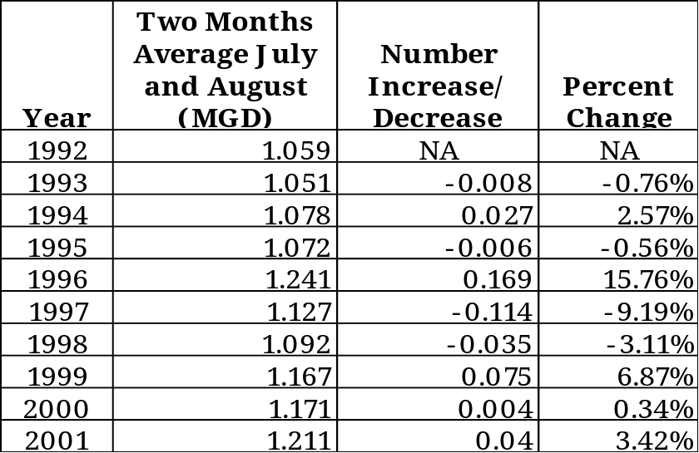
Source: CMCMUA

Currently the CMCMUA is obligated to provide up to 2.74 million gallons per day of flow capacity (monthly average) within the wastewater system for the Borough of Avalon’s needs at full build-out. The table illustrates that the highest two month average was in the year 2001 with 1.211 MGD. The Borough has also completed an infiltration and inflow control program.

The State of New Jersey prepares projected sanitary flow criteria for various uses using a measurement unit and gallons per day (GPD) for each use specified. Hotels are measured at 75 GPD per bedroom and three bedroom units are measured at 300 GPD. The Golden Inn is located in the R-M Zone in the southern section of the community and consists of 154 rooms. At 75 GPD those 154 units result in a sewer flow of approximately11,550 GPD. If the Golden Inn property were redeveloped with 20 two-family dwellings, there would be a total of 40 units. At 300 GPD those 40 units would result in a sewer flow of 12,000 GPD, an increase of 450 GPD, which is insignificant.

The one major change that would increase densities in Avalon is conditionally permitting second story residential in the B-1 Zone. This could result in 138 units or an additional 41,400 GPD of sanitary sewer flow.

Solid waste disposal and recycling
The Cape May County Municipal Utilities Authority (CMCMUA) retains records of solid waste tonnage generated for the municipality by year.

Table U2 - Solid Waste Tonnage 1994-2000
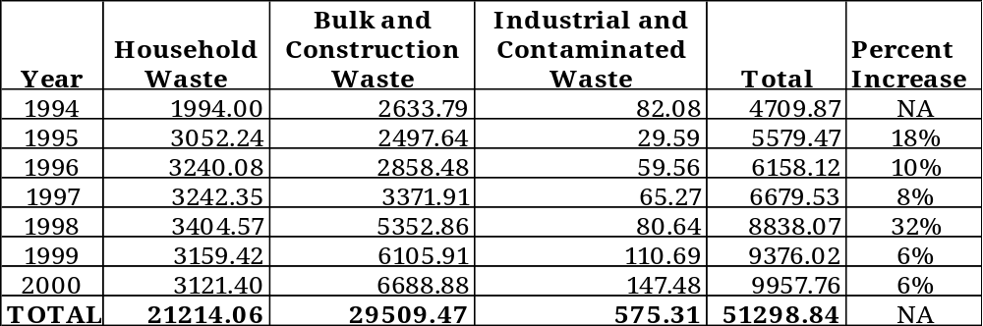Source: CMCMUA

Between the years 1997 and 1998 the greatest percent increase in the solid waste tonnage generated was 32%. The number reflects an increase in the bulk and construction waste tonnage from 3371.91 to 5352.86 or a 59% increase from 1997. The bulk and construction waste components continue to increase in 1999 and 2000 while household waste figures decline. Those figures are consistent with the authorized building permits data shown on Table D6, which reflects the demolitions and construction which occurred as a result of redevelopment.

The Planning Board is concerned about the impacts of any development or redevelopment on municipal services such as sanitary sewer capacity, water supply, and municipal waste generation. Any increase in density, such as those suggested for the hotels will increase impacts upon municipal services. Increases in density due to conditionally permitting residential uses on the second story in the B-1 Business Zone will increase demands on municipal services. With the exception of these two suggested changes in density, the Planning Board has not increased the densities in any portion of the community, rather the Planning Board is encouraging less bedrooms through increased parking requirements as well as a single family and two family residential maximum floor area ratio.

Conclusion
The authority to shape physical form fulfills several of the purposes of Planning. Specifically the Land Use Element, Housing Element, Utility Services Element, Transportation Element and the Community Design Plan fulfill several of the purposes of Planning as listed in the MLUL:

“To encourage municipal action to guide the use and development of all lands in this State in a manner which will promote the public health, safety, morals and general welfare.

To promote a desirable visual environment through creative development techniques and good civic design and arrangements.

To promote the conservation of open space and valuable natural resources in the State and to prevent urban sprawl and degradation of the land through improper use of the land.

To encourage the appropriate and efficient expenditure of public funds by the coordination of public development with land use policies.

To provide sufficient space in appropriate locations for a variety of residential, recreational, and commercial uses and open space, both public and private, according to their respective environmental requirements in order to meet the needs of all New Jersey citizens.

To encourage coordination of the various public and private procedures and activities shaping land development with a view of lessening the cost of such development and the more efficient use of the land.”

In conclusion, the Planning Board has sought to articulate and define the alterations required of the zoning and site plan and subdivision ordinances that have been discussed at workshop meetings and in reexamination reports since the 1990’s. The Planning Board seeks solutions to further enhance the community through implementation of the specific objectives listed in the body of the Master Plan.

Appendix A – Square Foot Comparison

